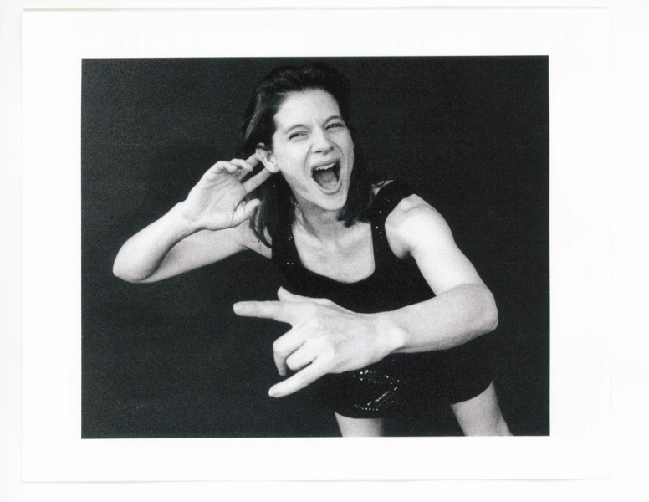
“Mom” with Ellis Wood
Posted on 22 June 2011 by Maura Donohue
Ellis Wood will be performing her evening-length solo “Mom” at NYU/Tisch this Friday at 7:30. I’ve known Ellis since we both performed solos for DTW’s Fresh Tracks back in 1995 and have seen early versions of this solo, which won last year’s DanceNow (NYC) Challenge. We spoke last month prior to (and then, just following) a performance of the work at Symphony Space.
Thanks for rescheduling due to my field trip chaperone duty conflict. I appreciated your comment about how it was appropriate to the subject matter, after all.

It was funny. A writer from the New Yorker was coming to rehearsal and called saying he’d lost childcare and was hoping he could bring his 5 month-old given the nature of my show.

It’s hard to do get things done with kids. I know that is just one aspect of “Mom”-ness, but the logistical, energy reserve, physical tolls are substantial. You can’t really know the full weight until you are in it. I often feel that the idolization of young, new voices (and bodies) in dance can create a focus in our field that ignores the realities for maturing artists – family responsibilities, aging, health care, etc. I remember the days of your Gender Project. Things felt very urgent and frustrating then. I now wonder whether things are truly different or if I simply am. Is it any easier to ‘make it’ in dance as a female artist or have we just altered our priorities enough that those other issues are still present, but mean less now?

Everything you are saying, I feel like I’m saying every day. You mentioned The Gender Project, I feel like in those days I fought a lot harder. Now, my energy is spent elsewhere – even though I notice what you are saying. I don’t fight through it. It has been different, to be in the dance world not fighting. I’m more interested in accepting what is and making my own path through, so that I feel fulfilled and happy and comfortable with what I’m able to put out there. This piece is not the biggest production that I’ve ever put on. Looking at it from the outside it seems not big in scale, but I’ve never been so nervous, insecure, proud and excited all at the same time. And, I can kind of remember this feeling from that first solo I did on that Fresh Tracks we were both in – in 1995. I remember needing the shift from dancing in other people’s companies to making my own way. I had this feeling of total rawness – and I feel that again 15/16 years later. I think finding Fran Kirmser, a development director I started working with 4/5 years ago, helped me shift to this moment. I felt lost in the dance world about what my next step was. She guided me toward finding what makes me happy. It keeps me honest. Well I’m certainly not going to do it if I’m miserable and just doing what other people think I should be doing. If this piece weren’t called “MOM” I wouldn’t have made it through. I can’t tell you how many times I couldn’t go to a rehearsal, with space paid for. I had one 6-week stretch where some kid in my family was sick and I couldn’t rehearse. And, the only way I could go back in was to say: “hey, this is what it means to be a mom.” I used to rehearse everyday for 4 hours a day. I used to be in a certain kind of shape and didn’t have 3 c-sections. I used to hold myself to such rules and I can’t do that any more. When I started back after my third child, if I went to rehearsal and created something new and my body didn’t hurt – it was such victory. I can’t believe I put this thing together. Anyone without a child knows getting a work up is a huge accomplishment and anyone who can do it with a child is amazing.

And, to do an evening-length solo that you told me (after performing part of it at the Fresh Tracks Gala at DTW) could only be done in a one-off situation.

I’ve actually built up to it be something I could do as a 2 or 3 night performance run. But, the build has been so slow. After my last kid (who is 2.5), it was difficult to do a second position plie. It’s taken me 2.5 years to be able to feel like I can do this piece and get through and not hurt myself and do it a few times in a row. I didn’t think I could pull myself together to do a solo. Funny enough it was my mom and Fran who were actually the ones saying: “Well, you could.” And I said no and that went on for a long time before they started to point out that I already was. A couple years ago I went back onstage and it was hard and it was a slow build. Then Robin Staff at DanceNow sent me that application for the Fall Festival and I thought, “I’m just going to do this!” It got me back and I am forever grateful. I needed something somewhere to make me do it. And, it felt so good. DTW was where I did my first solo.

I love that you came back with a solo called “MOM” and that it won DanceNow’s challenge. That seemed like a validating moment, saying maybe we are growing up and maybe opening to realities that valuable working artists can also be active parents. It seems to me that you are fighting by example now. It reminds me of a central theme in Joan Acocella’s “28 Artists and 2 Saints” book. How she said that female artists experience significant gaps or ends to their creative lives because the domestic burdens of caring for other human beings (young or old) fell most often on them. I don’t think that has changed that substantially, but I’d like to think more of us are managing to maintain both rich personal and creative lives.

Sometimes there’s that gap and sometimes there’s a departure. There’s a certain kind of push that I don’t want to do have anything to do with, the push from ten years ago. That’s kind of what Fran guided me away from, and why I did this piece. The reality is that my kids have to go to school and eat and considerations include finances, time, energy, how do I split my life and all those things. I do the bulk of scheduling and doctor’s and dentists and I have to be available if somebody’s sick and how does dance work around this. I had these two incredible women who were mothers who gave me a vote of confidence and I needed that. Also, the video artist Robyn Tomlin, who is a single mother, stepped in – and the project really started coming together. I’d love to say that I was all confident moving forward, but I needed some votes of confidence. My mother, pregnant 5 times in 4 years and losing 2 of them while dancing with Martha Graham, knew what she was talking about too. While in the middle of dancing in Martha’s company, she suffered all those changes to her body. God knows that was insanely difficult, but Martha was always clear that she could come back after having the kids.

So, how does this all make its way into the work? Or does it?

It’s about 45 minutes and there are different sections and each represents a different time and vibe in a mother’s life. There are two sections that are the most intense or poignant for me. About half way in, there is a section with an elastic band. Most everything before that leads up to getting pregnant. The band represents an umbilical cord and most everything after represents life after kids. What I do during that section is intricate enough that it’s all I can concentrate on – which is different from my usual looking out at the audience and playing with expressivity. It’s all I can do to get through this section and it feels very real. Sometimes you’re doing the world out there and it’s crazy and then there are moments – pregnant, giving birth, with the kids – where you’re tangled and caught and also maneuvering through it with great intricacy and I know this is Freudian but I’m really attached to this section. Also the last section is special to me because it is the first one I made.

How did the piece go? What was it like to perform this work?

Better than I had imagined. Doing it just made me want to do it more. Something about doing it for the first time meant that I could live in it in a very real way. I couldn’t fake much because it was so raw – I felt like I was living in the moment. My kids, husband and my sister and my own mom were there and I love that. Dancing is a place where I can actually be something other than a wife and mother at this point– so it means a lot to me for them to see that part of me as well. There are certain things – even about motherhood – that I only express on stage. How funny that a stage seems like such a safe place for me to express some things I don’t quite know how to express in my life. Anyway, I am going to keep working on the piece and will continue to do it for a while. Thanks for asking.

